Canadian Setup Instructions for OpenEdge

This setup document assumes the EdgePay software has been loaded on to the server. If not, make sure it is loaded.

1. Install the RCM Service

From IE, type the base IP address for the server.
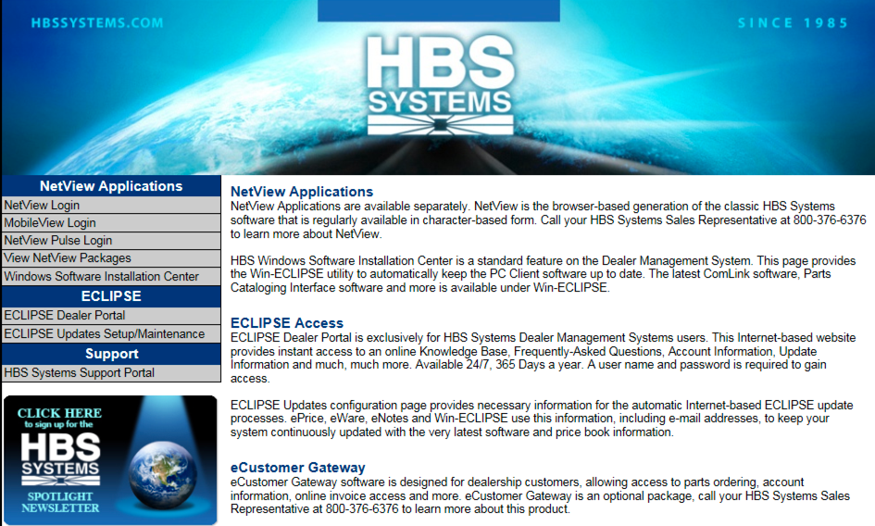

Choose the Windows Software Installation Center option on the left side.

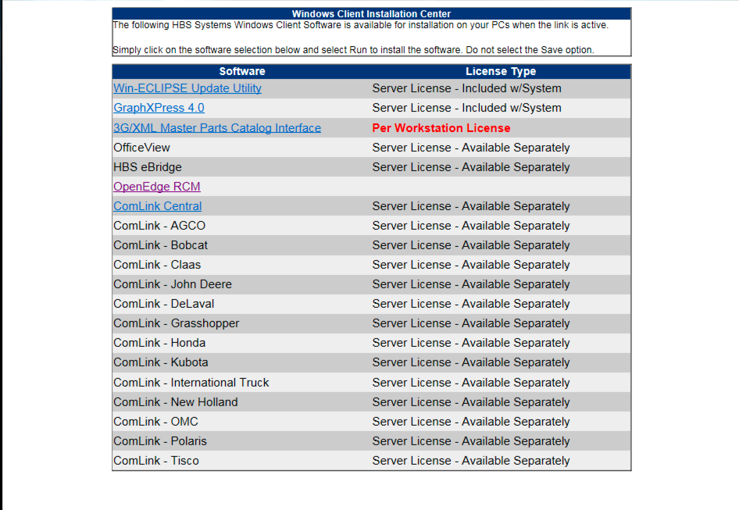

From the list, choose the OpenEdge RCM item. Run the installer. If asked for the administrator's password, enter it.
2. Check the RCM Installation

The RCM module should already be running.

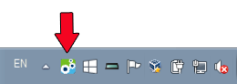

A payment terminal should be attached to the computer, turned on and at a ready state.

Right click the RCM icon on the task tray.

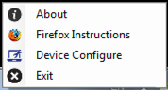

Choose the Device Configure item.

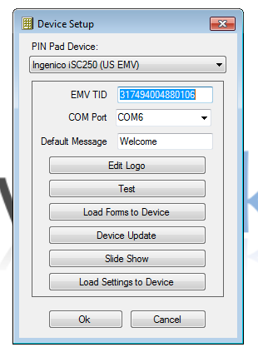

The COM Port should be set. If not, the device is not plugged in or not configured.

Select the test option. If the test does not pass, get assistance from hardware support.

Select the Load Setting to Device option. If the test does not pass, get assistance from hardware support.

Select the Load Forms to Device option. If the test does not pass, get assistance from hardware support.
Select the Device Update option. If the device is not up to date, it will automatically update the device.

If the tests fail, you may need to install this hot fix (https://support.microsoft.com/en-us/kb/929852).

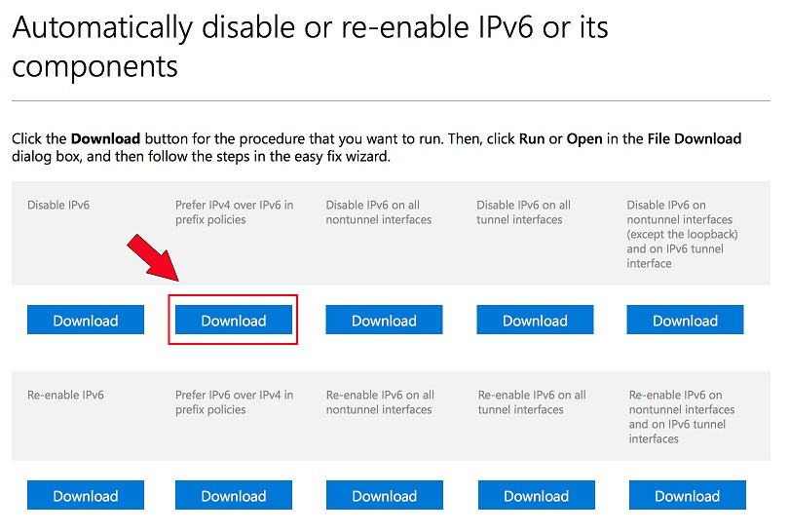

Download the “Prefer IPv4 over IPv6 in prefix policies” package.

Install.

3. Setting Up the Terminal

Connect the terminal BEFORE configuring the settings. This will ensure certain data populates automatically.

4. Configure CCDI

Run CCDI from the Netview home page.
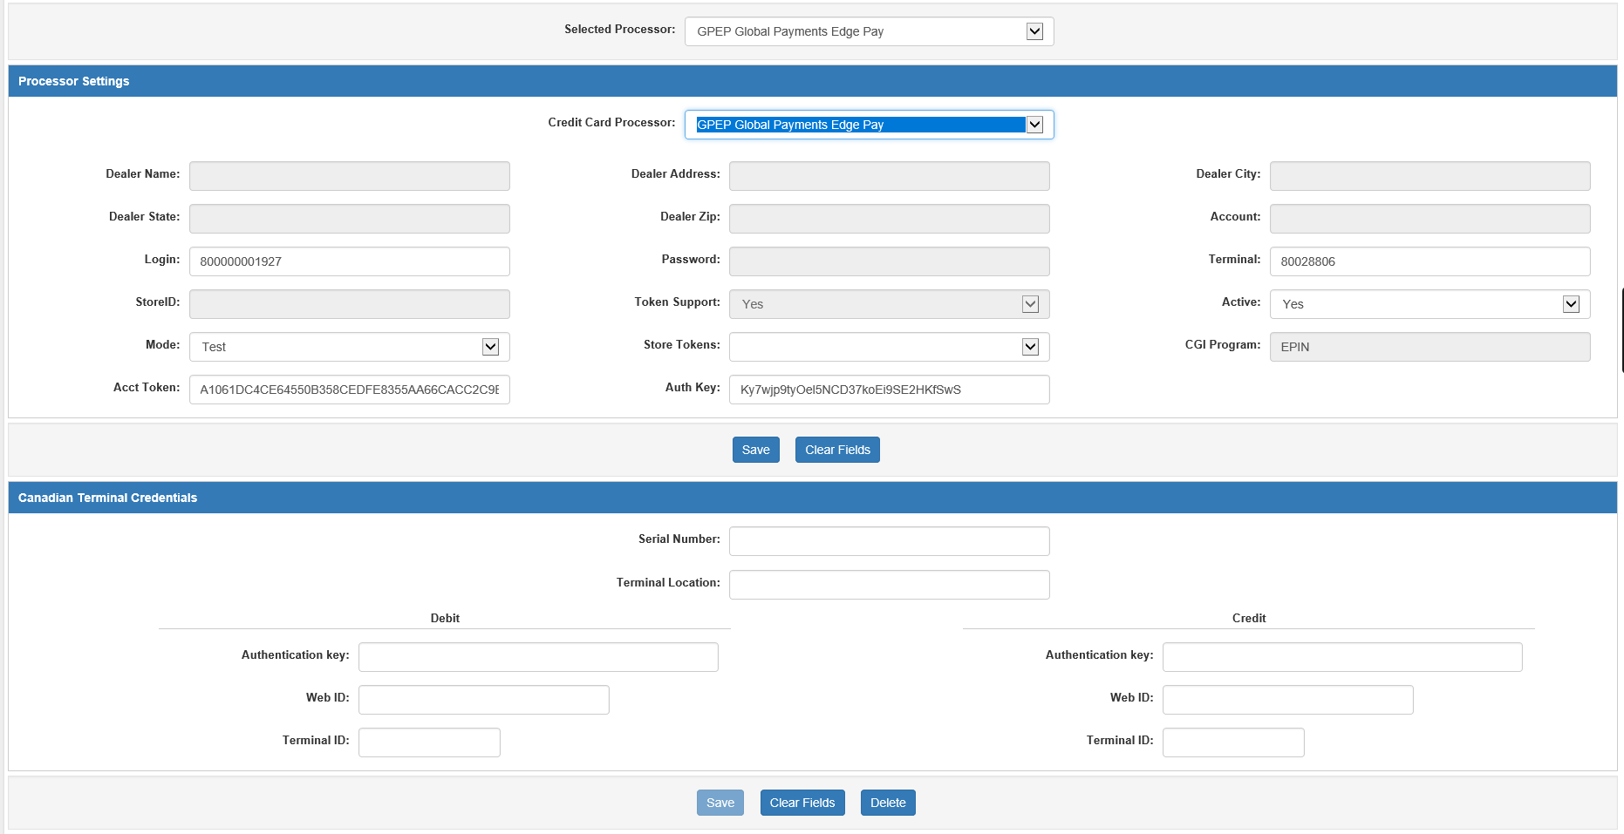

Change the Selected Processor field at the top of the screen to GPEP Global Payments.

In the Processor Settings, make sure GPEP Global Payments is set to YES in the Active field.

In the Canadian Terminal Credentials, the Serial Number field should automatically be populated provided the terminal is connected. If there is already information corresponding with that serial number, the rest of the fields should auto-populate as well.

Name the Terminal Location. This will indicate where in the dealership the processor is located (Parts1, Rental5, etc.).

5. Obtaining the X-Web credentials

In the Processor Settings, enter the Login, Terminal, Auth Key, and Acct Token from the merchant account sheet provided by OpenEdge and the Support Supervisor. This data can be found in the encrypted PDF document sent with the main merchant credentials.

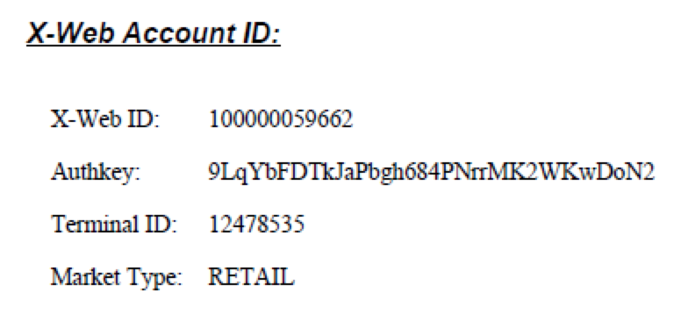

The Account Token should be generated following the instructions on the main merchant credential form.

In the Canadian Terminal Credentials, enter the separate information provided for Debit and Credit charges (Auth Key, Web ID, Terminal ID). Note that these may auto-populate based on serial number.

Save the changes.

Quit CCDI.

6. Test OpenEdge and Terminal

Create a temporary ticket in POS.

Enter a TEST O part with a random amount.

Settle the ticket. Select a credit card MOP.

If a credit MOP does not show in the list, exit POS and configure the credit card MOPs in MOP.

Tab through the settlement line to display the EPIN program.

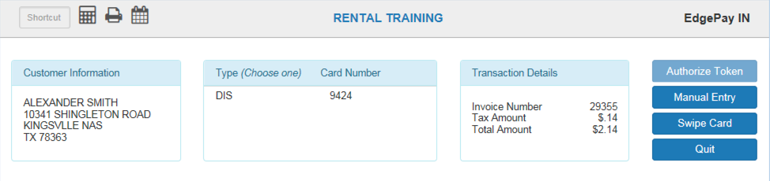

Choose the Swipe Card option on the right side.

When prompted at the terminal, swipe the card and confirm the amount.

The system should return an error. This is OK.

Exit POS.

If the terminal did not work correctly, or the EPIN program did not show, consult software.

7. Activate Production Mode for GPEP

Run CCDI from the Netview home page.

Set the Credit Card Processor field to GPEP.

Make sure that the Mode field is set to Production.

Save Changes.

Exit CCDI.

8. Migrate Credit Cards

Get a terminal session running to run a fix program.

Determine if the CRCARD database is linked or standalone in each location.

Run ../fix/fixcrdtok in each location that has an unlinked CRCARD database.

Capture any errors and forward them to the software department for analysis.

